Custom Mobile App - Footprints

# Summary

This Footprints v1 app was the result of a brainstorm between Christopher Park and David Cowart. The idea was to create an app that would allow for the tracking of outdoor sales people as they canvas various areas and leverage the Sitefinity Module Builder, Mobile App Builder and its Geolocation capabilities. The app would then store the data in Sitefinity allowing for reporting and exporting of the data to csv files. This app could also be used for such as surveying/polling, civil issues collection and various other scenarios.

For v1 the user will add the following properties for each entry:

* Title
* Summary
* Name *
* Address **
* Image

*\* I was not able to get it working, but I’m hoping I can auto-pull the name of the user when logged in.*

*\*\* In future releases I would like to auto-pull the geolocation coordinates of the device when a picture is taken.*

This data will be stored in a Sitefinity custom module. A custom widget has been created to read the data from this module and display it in a Radgrid control. This widget also has an export functionality that allows the user to save the data to a csv file.

Working on adding a tab control to allow for the selection of “All” users and particular Users to help make the data more user friendly within Sitefinity.

# Screenshots

## Module Builder

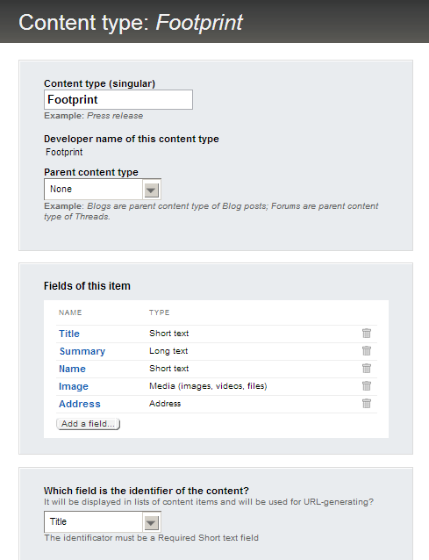

## Footprint Content Item

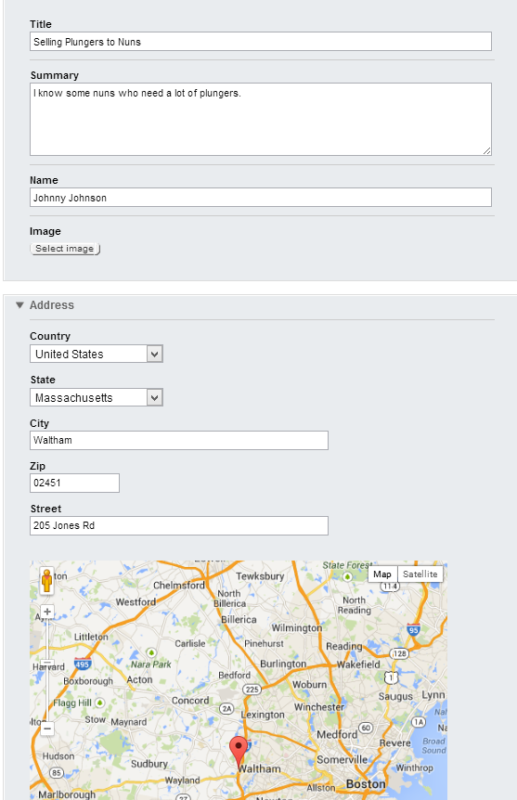

## Footprints Mobile App List View

## 

## Footprints Mobile App Detail View

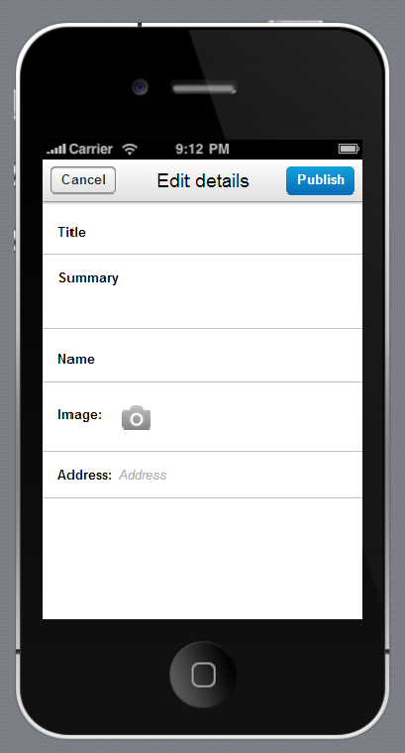

## Footprints Mobile App Detail View 2

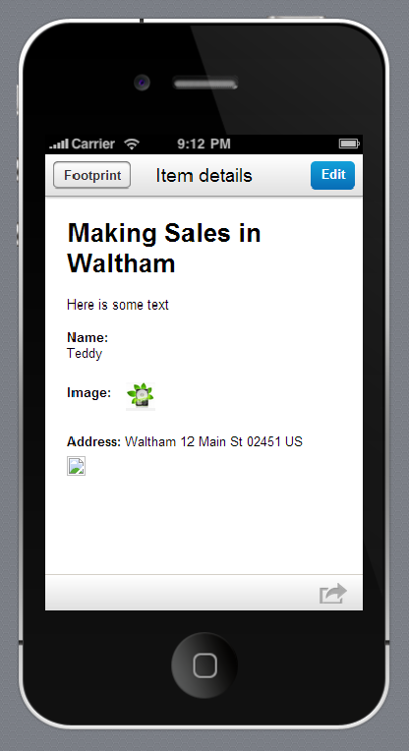

## Footprints Mobile App Detail View Maps and Image

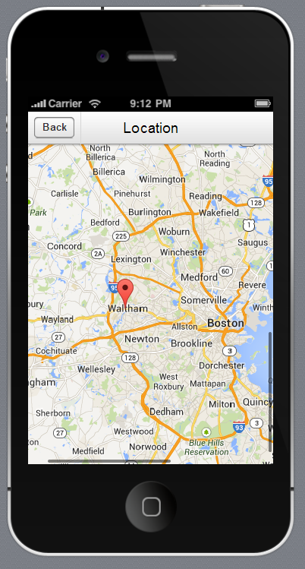 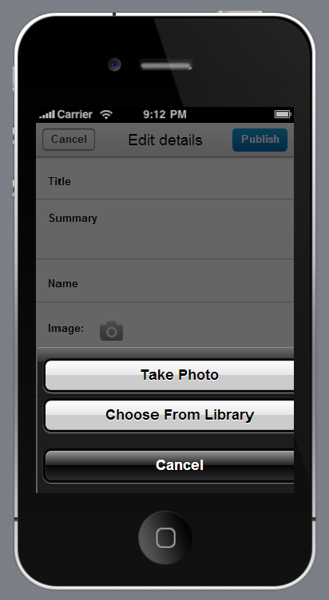

# Sitefinity Footprint Custom Widget w/ Rad Grid

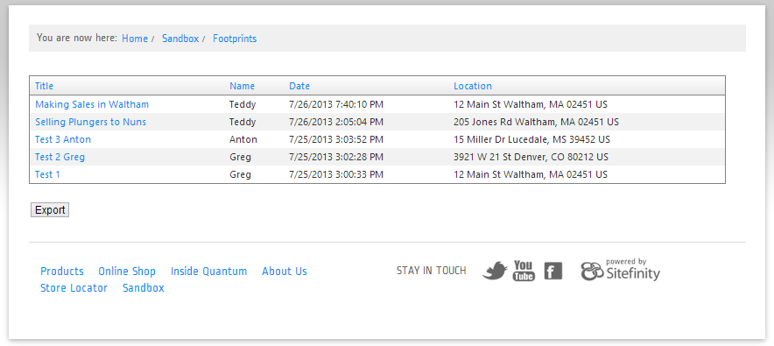

## Sitefinity Footprint Custom Widget Data Export

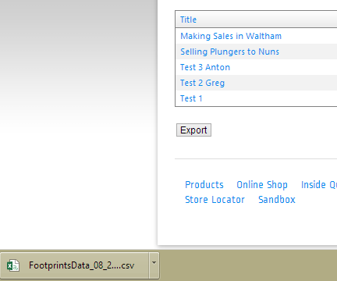

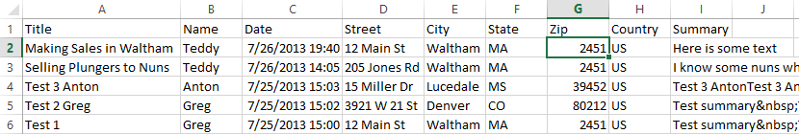

# Going Forward

In the future I’d like to include a RadTabstrip control in conjunction with a RadGrid control where the tabs could be separate user names and when they’re clicked on would load the data for that particular user. This would make the data more user friendly for the person administering and consuming the data.

I’d also like to create a map that would list all the geocoordinates for each user during a range of time. For example the administrator would select a user, then set a time range, hit submit and a map listing all the locations that user had been during that range would be displayed.